# CS 255 System Design Document Template

This template lays out all the different sections that you need to complete for Project Two. Each section has guidance to prompt your thinking. You will need to continually reference the interview transcript as you work to make sure that you are addressing your client’s needs. There is no required length for the final document. Instead the goal is to complete each section based on what your client’s needs are. Remove this note when you are finished, and replace all bracketed text with the relevant information.

## UML Diagrams

### UML Use Case Diagram

### UML Activity Diagrams

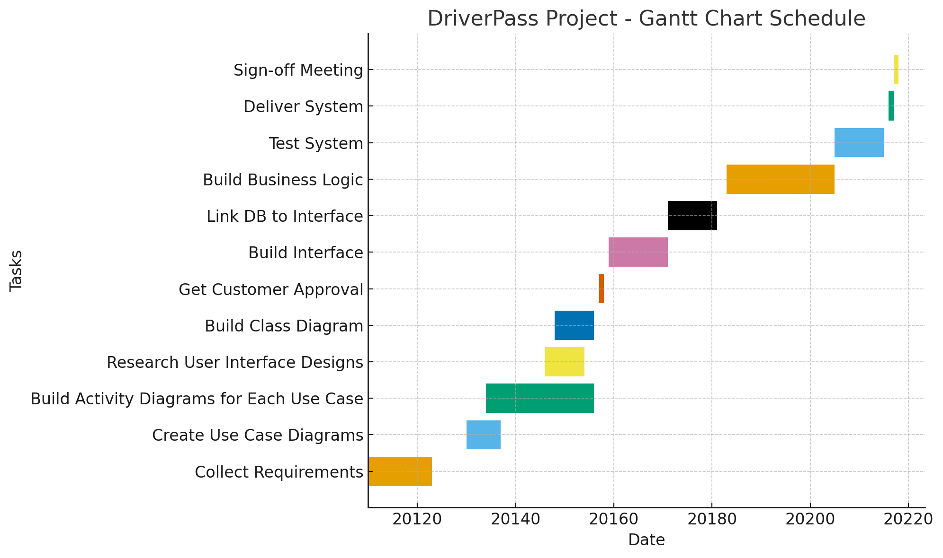

## Technical Requirements

The DriverPass system requires a dependable blend of hardware, software, tools, and infrastructure to function effectively. On the hardware side, the project will rely on cloud-hosted servers with sufficient CPU and memory to support peak activities such as scheduling lessons, processing payments, and running practice tests, while local development can be handled on modern laptops or desktops with at least 16 GB of RAM. For the software stack, a relational database such as PostgreSQL or MySQL will manage structured data, a backend framework in Python or Java will handle logic and transactions, and a responsive JavaScript framework will support the user interface across devices, with third-party services like Twilio or Firebase used for notifications. Development tools include Git for version control, automated testing suites, and CI/CD pipelines to ensure smooth and reliable updates, along with monitoring tools such as Splunk or ELK to provide visibility into performance and system health. The infrastructure will be deployed in a cloud environment such as AWS or Azure, using containerization technologies like Docker to keep services modular and portable, and every component will be secured with encryption in transit and at rest, daily backups, and strict access controls. Together, these requirements ensure the system is reliable, secure, scalable, and able to deliver a seamless experience for students, instructors, and administrators while leaving room for future enhancements.